International Revista of Physics, Chemistry, Mathematics and Biology  (ISSN: xxxx-xxxx)  Vol1, Issue 1, (2026) | https://irpcmb.com/

Applying Absolute Residuals as Evaluation Criterion for Estimating the Development Time of Software Projects by Means of a Neuro-Fuzzy Approach
Noel García-Díaz1,2*, Alberto Verduzo-Ramirez 1,2, Juan Garcia-Virgen 1,2, Lilia Muñoz3
1Instituto Tecnológico de Colima, MÉXICO
2Universidad de Colima, MÉXICO
3Universidad Tecnológica de Panamá, REPUBLICA DE PANAMÁ
*Corresponding Author: ngarcia@itcolima.edu.mx

Citation: García-Díaz, N., Verduzo-Ramirez, A., Garcia-Virgen, J. and Muñoz, L. (2026) Applying Absolute Residuals as Evaluation Criterion for Estimating the Development Time of Software Projects by Means of a Neuro-Fuzzy Approach, International review of physics, chemistry, mathematics and biology, 1:1 (2026).
Received: Jan 14, 2026; Accepted: April 24, 2026; Published: June 4, 2026
Abstract
In the software development field, software practitioners expend between 30% and 40% more effort than is predicted. Accordingly, researchers have proposed new models for estimating the development effort such that the estimations of these models are close to actual ones. In this study, an application based on a new neuro-fuzzy system (NFS) is analyzed. The NFS accuracy was compared to that of a statistical multiple linear regression (MLR) model. The criterion for evaluating the accuracy of estimation models has mainly been the Magnitude of Relative Error (MRE), however, it was recently found that MRE is asymmetric, and the use of Absolute Residuals (AR) has been proposed, therefore, in this study, the accuracy results of the NFS and MLR were based on AR. After a statistical paired t-test was performed, results showed that accuracy of the New-NFS is statistically better than that of the MLR at the 99% confidence level. It can be concluded that a new-NFS could be used for predicting the effort of software development projects when they have been individually developed on a disciplined process.
Keywords: Artificial neural networks, fuzzy logic, neuro-fuzzy system, Software effort estimation, absolute residuals

INTRODUCTION
A high percentage of machine learning models have been proposed based on an accuracy asymmetric criterion Magnitude of Relative Error (MRE) (Wen et al., 2012), however, it was recently found that MRE is asymmetric and that the use of the Absolute Residual (AR) should be used instead because of AR is unbiased and it is does no lead to asymmetry (Shepperd & MacDonell, 2012). The AR criterion has been already used in recent publications for estimating the effort (López-Martín, 2015) and schedule (duration, time) (Ferreira-Santiago et al., 2015) of software projects.

RELATED WORK
A systematic review of 157 studies published between the years 2002 and 2012 involved the application of NFS (Kar et al., 2014). This review classifies the NFS applications into ten different categories, and in none of them was found any study regarding SDEE, therefore, in this study a NFS is proposed as a new model to compare its results to a MLR.
Additional estimation techniques have been proposed into the area of SDEE to improve estimation accuracy (Wen et al., 2012; Jørgensen & Shepperd, 2007).
A systematic review of 84 studies analyzed machine learning models specifically applied to SDEE (Wen et al., 2012). This review involved empirical studies published in the last two decades (1991–2010). After analyzing these studies, by Wen et al., found eight types of machine learning techniques applied to SDEE; however, it was not found any paper using data from small projects and basing its conclusions on AR and having a NFS using a Grid partitioning method to obtain the parameters for input and output of the membership functions (MF).
A second systematic review completed in 2004 identified 304 SDEE studies in 76 journals (Jørgensen & Shepperd, 2007). It classified the studies according to their research topic, estimation approach, research approach, study context and data set. In this review, it was not including any neuro-fuzzy model used for SDEE.
A NFS to estimate software projects development time was built by (Marza et al., 2008). The forty-one modules developed from ten software projects were used as data set. The proposed approach was compared with FL and NN model and results showed that the value of MMRE applying NFS was substantially lower than MMRE applying FL and NN.

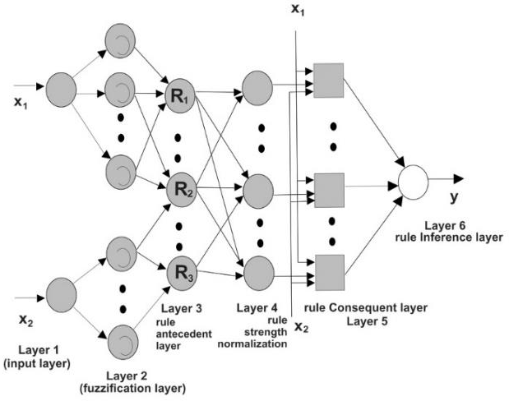
Figure 1. Neuro-fuzzy system.

Table 3. MAR of each module (MLR: Multiple Linear Regression, NFS: Neuro-Fuzzy System, MAR: Mean of Absolute Residuals).

Module | Actual Time | AR - MLR | AR -New-NFS
1 | 13 | 2.06 | 0.0003
2 | 13 | 2.36 | 0.0000
3 | 9 | 0.80 | 0.0001
4 | 15 | 3.20 | 0.0001
5 | 15 | 1.63 | 0.0000
6 | 15 | 1.87 | 0.4999
7 | 16 | 0.87 | 0.5001
8 | 16 | 0.62 | 0.0001
9 | 16 | 0.42 | 0.0073
10 | 18 | 2.47 | 0.0129
11 | 15 | 0.43 | 1.0068
12 | 15 | 0.43 | 1.0068
13 | 18 | 2.57 | 1.9932
14 | 13 | 1.35 | 0.9952
15 | 14 | 0.35 | 0.0048
16 | 15 | 0.65 | 1.0048
17 | 13 | 1.10 | 0.0009

REFERENCES
J. Wen, S. Li, Z. Lin, Y. Hu, C. Huang, “Systematic literature review of machine learning based software development effort estimation models,” Information and Software Technology, 54 (2012) 41–59.
M. Shepperd, S. MacDonell, “Evaluating prediction systems in software project estimation”, Information and Software Technology, Volume 54, pp. 820–827, 2012. doi:10.1016/j.infsof.2011.12.008
C. López-Martín Predictive accuracy comparison between neural networks and statistical regression for development effort of software projects Appl. Soft Comput., 27 (2015), pp. 434–449. http://dx.doi.org/10.1016/j.asoc.2014.10.033
A. Ferreira-Santiago, López-Martín, C., & Yáñez-Márquez, C. (2015). Metaheuristic optimization of multivariate adaptive regression splines for predicting the schedule of software projects. Neural Computing and Applications, 1-12.
A. Abran, J. W. Moore; editors, P. Bourque, R. Dupuis, “Guide to the Software Engineering Body of Knowledge (SWEBOK),” IEEE Computer Society, Pp. 1–1, 2004.
Standishgroup.com, “The Standish Group ©,” www.standishgroup.com, 2012.
R.A. De Araújo, S. Soares, L.I. Oliveira, “Hybrid morphological methodology for software development cost estimation,” Expert Systems with Aplications, Pp. 6129-6139, 2012.
A. Bonneti, S. Bortot, M. Fedrizzi, R.A. Marques Pererira, A. Molinari, “Modelling group process and effort estimation in project management using the Choquet integral: An MCDM approach,” Expert Systems with Aplications, 2012.

